**SOURCE CODE**

1)

section .data

hello db 'HELLO WORLD',4

helloLen equ $-hello

section .text

global _start

_start:

mov eax, 4

mov ebx, 1

mov ecx, hello

mov edx, helloLen

int 80h

mov eax, 1

mov ebx, 0

int 80h

OUTPUT



2)

section .data

star times 9 db '*'

section .text

global _start

_start:

mov eax, 4

mov ebx, 1

mov ecx, star

mov edx, 9

int 80h

mov eax, 1

mov ebx, 0

int 80h

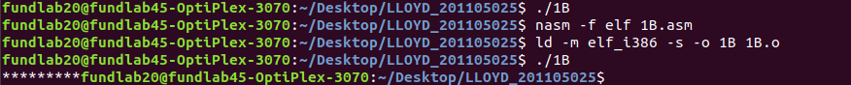OUTPUT

3)

section .data

mssg1 db 'HELLO WORLD',10

mssg1Len equ $-mssg1

mssg2 db 'HELLO USER',10

mssg2Len equ $-mssg2

sys_exit equ 1

sys_write equ 4

stdin equ 0

stdout equ 1

section .text

global _start

_start:

mov eax, sys_write

mov ebx, stdout

mov ecx, mssg1

mov edx, mssg1Len

int 80h

mov eax, sys_write

mov ebx, stdout

mov ecx, mssg2

mov edx, mssg2Len

int 80h

mov eax, sys_exit

mov ebx, stdin

int 80h

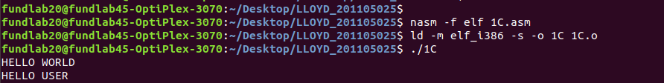OUTPUT

4)

section .data

sys_exit equ 1

sys_write equ 4

stdout equ 0

name db 'GCE GOA',10

nameL equ $-name

section .text

global _start

_start:

mov eax, sys_write

mov ebx, stdout

mov ecx, name

mov edx, nameL

int 80h

mov[name], dword 'GEC '

mov eax, sys_write

mov ebx, stdout

mov ecx, name

mov edx, nameL

int 80h

mov eax, sys_exit

mov ebx, stdout

int 80h

OUTPUT

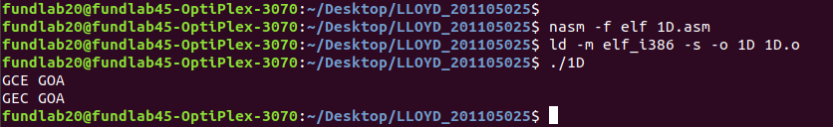

5)

section .data

st db 'HELLO WORLD',10

stt db 'HELLO GEC',10

section .text

global _start

_start:

mov eax, 4

mov ebx, 1

mov ecx, st

mov edx, 12

int 80h

mov eax, 4

mov ebx, 1

mov ecx, stt

mov edx, 10

int 80h

mov eax, 1

mov ebx, 0

int 80h

OUTPUT

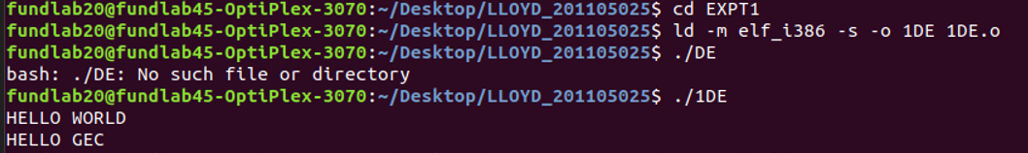

6)

section .data

sys_out equ 4 ;To output

sys_in equ 3 ;To Input

stdout equ 1 ;Stdout

stdin equ 2 ;Stdins

p1 db 'ENTER YOU NAME: '

p1L equ $-p1

p2 db 'ENTER THE NUMBER: '

p2L equ $-p2

p3 db 'YOUR NAME IS: '

p3L equ $-p3

p4 db 'YOUR NUMBER IS: '

p4L equ $-p4

section .bss

num resb 9

name resb 9

section .text

global _start

_start:

mov eax, sys_out

mov ebx, stdout

mov ecx, p1

mov edx, p1L

int 80h

mov eax, sys_in

mov ebx, stdin

mov ecx, name

mov edx, 9

int 80h

mov eax, sys_out

mov ebx, stdout

mov ecx, p2

mov edx, p2L

int 80h

mov eax, sys_in

mov ebx, stdin

mov ecx, num

mov edx, 9

int 80h

mov eax, sys_out

mov ebx, stdout

mov ecx, p3

mov edx, p3L

int 80h

mov eax, sys_out

mov ebx, stdout

mov ecx, name

mov edx, 9

int 80h

mov eax, sys_out

mov ebx, stdout

mov ecx, p4

mov edx, p4L

int 80h

mov eax, sys_out

mov ebx, stdout

mov ecx, num

mov edx, 9

int 80h

mov eax, 1

mov ebx, 0

int 80h

OUTPUT

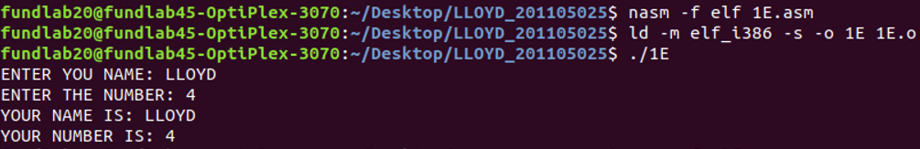

7)

section .bss

num1 resb 9

num2 resb 9

section .data

sys_out equ 4 ;To output

sys_in equ 3 ;To Input

stdout equ 1 ;Stdout

stdin equ 2 ;Stdins

p1 db 'ENTER THE FIRST NUMBER: '

p1L equ $-p1

p2 db 'ENTER THE SECOND NUMBER: '

p2L equ $-p2

p3 db 'THE NUMBER YOU ENTERED ARE: ',10

p3L equ $-p3

section .text

global _start

_start:

mov eax, sys_out

mov ebx, stdout

mov ecx, p1

mov edx, p1L

int 80h

mov eax, sys_in

mov ebx, stdin

mov ecx, num1

mov edx, 9

int 80h

mov eax, sys_out

mov ebx, stdout

mov ecx, p2

mov edx, p2L

int 80h

mov eax, sys_in

mov ebx, stdin

mov ecx, num2

mov edx, 9

int 80h

mov eax, sys_out

mov ebx, stdout

mov ecx, p3

mov edx, p3L

int 80h

mov eax, sys_out

mov ebx, stdout

mov ecx, num1

mov edx, 9

int 80h

mov eax, sys_out

mov ebx, stdout

mov ecx, num2

mov edx, 9

int 80h

mov eax, 1

mov ebx, 0

int 80h

OUTPUT

